PyNet2 Installation Visual Guide

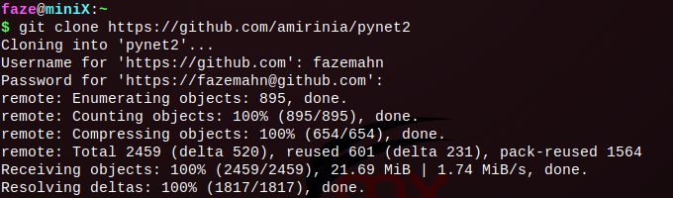

Firstly, clone the repository using the ‘git clone’ command and use your credentials when prompted. If you have access to the repository, you should be able to clone it.

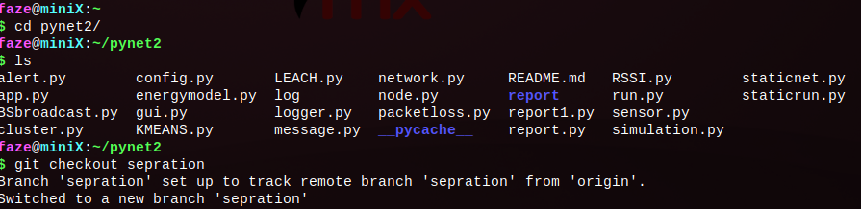

Navigate into the pynet2 folder by using the ‘cd’ command.

Additional Step for current release:

Use the ‘git checkout’ command to switch into the ‘sepration’ branch of the code. This will not be necessary as soon as the branch is merged onto the master branch when development is completed.



Depending on your GNU/Linux distribution or Windows, an installation of the pip package manager is necessary to proceed.

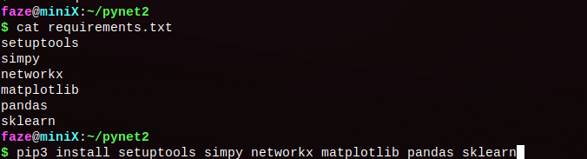

All the required modules are listed in the requirements.txt file. Simply use ‘pip install’ and list all the modules in a space separated manner. This command will download all the required modules to run an instance of PyNet2.

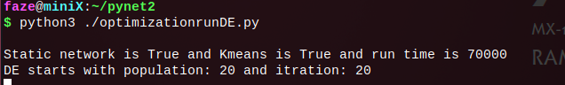

Use the ‘python3’ command to run any script.